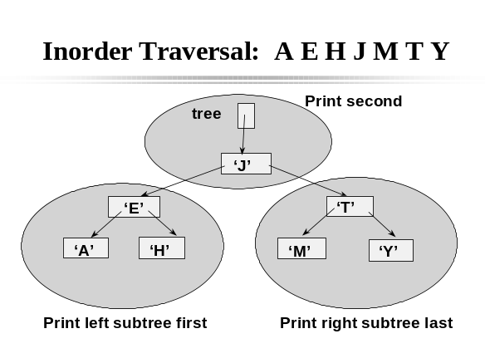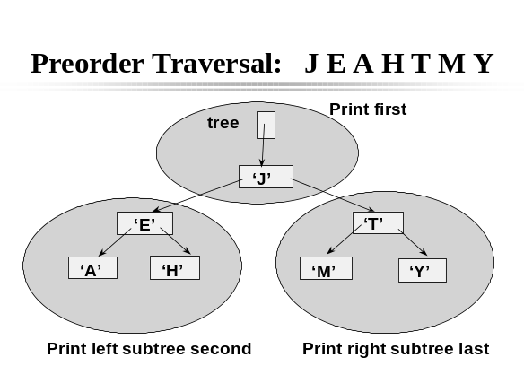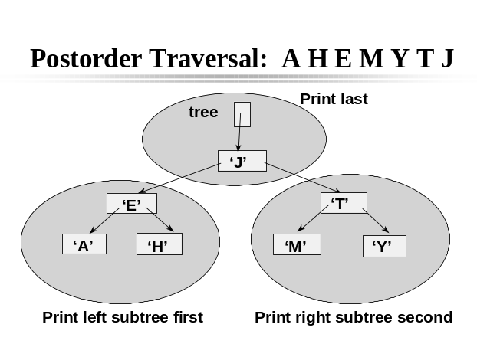

PostOrder Traversal

For every node :
- Visit the left subtree of that node
- Visit the right subtree of that node
- Print that node

InOrder Traversal

For every node :
- Visit the left subtree of that node
- Print that node
- Visit the right subtree of that node

PreOrder Traversal

For every node :
- Print that node
- Visit the left subtree of that node
- Visit the right subtree of that node

